Knowing mathematics for, and in, the future: Socio-ecological explorations of relational epistemology
Lisa Björklund Boistrup, NMS/SDRC, Malmö University, Malmö, Sweden, lisa.bjorklund.boistrup@mau.se
Yasmine Abtahi, University of South Eastern Norway, Bergen, Norway, yasmine.abtahi@usn.no
Frankie Fran, Ateneo de Manila University, Romblon State University, Philippines, frankie.fran@student.ateneo.edu
Jenny Fred, IÄD, Stockholm University, Stockholm, Sweden, jenny.fred@su.se
Ramiro Carrillo-Catalán, Universidad Pedagógica Nacional Oaxaca - Secihti, Mexico, rcarrillo@g.upn.mx
Abstract
Reflecting on the urgent need for mathematics education to engage with global socio-ecological challenges, this chapter presents socio-ecological explorations of relational epistemology to rethink what knowing mathematics for, and in, the future entails. We conceptualize the future as a relational and fluid construct, advocating for epistemological pluralism and the dismantling of extractive colonial logics. To address the complexity of knowledge and knowing, we propose a dual theoretical lens: transdisciplinary spaces and interrelational epistemology. Three cases are used for the exploration of relational epistemology for the future: (1) sustainable material practices in vocational mathematics; (2) contextualized Indigenous mathematical knowings rooted in communal ethics of just distribution; and (3) the integration of socio-ecological value conflicts into early algebra. Ultimately, this chapter highlights how bringing together transdisciplinarity and interrelationality moves beyond merely adding real-world contexts to mathematics. Instead, it offers tools to reimagine mathematics as a system of knowing that illuminates our profound interdependence and ethical responsibilities toward the human and more-than-human world.
Key words
Epistemology, relationality, transdisciplinarity, socio-ecological, mathematics education

Introduction
In the writing of this chapter, we, as authors from different parts of the world, explore epistemological aspects that we propose as highly relevant for mathematics education to truly engage with the socio-ecological in, and for the future. What we try to do is to respond to the question posed by Barwell et al. (2022), about the ongoing global ecological crisis and what it may have to do with mathematics education. When doing this, we conceive the future as relational and fluid, neither individualistic nor static, and as a social and ethical responsibility (see e.g. Abtahi, 2022 & Abtahi in ICMI study 27). To us, the desired future is not one where scientific/Western knowledge in mathematics saves the world, but one based on epistemological pluralism and transdisciplinarity, integrating physical reconnection with the Earth and subverting hegemonic ways of thinking. That would be a future which included the dismantling of systems of oppression, extraction, and degradation of both people and the planet (Todd, 2018), in which knowledge-other-than-school-mathematics, such as Indigenous knowledge, is not extracted or marginalized, but integrated into the core of the curriculum to give meaning to mathematics education (Gutiérrez, 2022). What we explore in the chapter are ways to work with, and understand, mathematics where the mathematical content itself is not seen as distant and neutral, but rather directly interconnected with the world we all live in, and its complexities and challenges (Skovsmose, 2023). Our (limited but hopefully relevant) contribution to such a future is that we in this chapter explore what knowing mathematics for, and in, the future, including socio-ecological challenges, might entail, and in this exploration our emphasis is on epistemology in connection to different kinds of relationalities.
Relationality has been explored in the field of mathematics education, from multiple dimensions. Of relevance here is how Boylan (2017) discusses relational knowing and being as a philosophical and theoretical basis for an ecologically informed mathematics curriculum. He explains relational knowing as an awareness of one's relationships with mathematics and with other actors (human, non-human and other materialities). He further explains that relationships constitute the “assemblage of mathematics as sociocultural-material-discursive practices” and therefore relational knowing would include “knowledge of ways mathematics mediates these relationships” (p. 4). In our explorations in this chapter, we try to reflect such relationships through different epistemological frameworks. When we address the social in socio-ecological, this includes ethics. Ethical relationality is addressed by Chen (2023) who rethinks agency, justice, and praxis for mathematics teachers concerned with addressing mathematical violence. Maheux and Roth’s (2011) conceptualization of relationality in knowing also has relevance to our explorations. They illustrate that knowing arises from a threefold relationality between (a) the subject and the material world, (b) the subject and others, and (c) the subject and itself. They argue that knowledge is not something that is personally "constructed" by rational, autonomous and culture-free individuals. Rather, relationality and knowing-with-in express the situated and situating nature of knowing in action. In this chapter we explore relationality in epistemology in two ways, where one is epistemological aspects that are present in transdisciplinary education, and one is the epistemology of individuals' potential relationalities with webs of other “things”, including knowings. These explorations are our ways to experience and emphasize mathematics as it may be integrated with matters of the Earth, not least socio-ecological matters.
Inspired by Capone (2022), our view is that in transdisciplinary education, relations between disciplines are being elaborated on, and there is also a common goal: in a transdisciplinary dimension. In this chapter, we explore aspects of knowing when disciplines (not to be taken only as academic entities) are integrated with mathematics, and the webs that these meetings form with learners, and other humans and non-humans (Abtahi, 2026). Also, we view it as essential, when addressing knowing mathematics for and in the future, keeping in mind socio-ecological issues, to take into account complexities and aspects which concerns epistemic (in)justice, in the sense of what knowing, and whose, is counted, and in what ways (Gutiérrez, 2019). For this chapter’s approach to transdisciplinarity, we are inspired by Johansson et al. (2024), which is a framework for reflecting a space of two (or more) dimensions, where mathematics and other-than-school-mathematics knowings are connected and/or integrated. This chapter’s approach to relationality draws upon ancient Persian philosophy and epistemology (see Abtahi, 2022), with a framework on interrelationships in the process of knowing and knowledge. This epistemology is about knowing one’s position in interpreting and engaging with the webs of other things (such as mathematical concepts) and with the multiplicities of one’s experiences.
For our explorations we use three cases, all deriving from our previous research. What we aimed for in choosing these cases was to connect to at least two different parts of the world, but more important was that the cases would reflect different kinds of contexts for mathematics education and relationalities. Our choices were the following:
- A context where students learn mathematics as part of their future work. Here we explored a case of vocational education with students who study to become electricians
- A context of indigenous knowing. Here we explored a case where indigenous mathematics knowings were put in relation to school mathematics.
- A context of a primary school mathematics classroom. Here we explored a case where the socio-ecological was integrated into early algebra
The first and last case are located in Sweden, whereas the second is from the Philippines. When we explore the cases through the epistemologies of transdisciplinarity and interrelationality, we aim to articulate how we can imagine a future of mathematics teaching and learning incorporating socio-ecological concerns, at its heart.
In the following, we start with the framework on transdisciplinarity to explore the cases. In the subsequent section, we adopt the interrelationality framework to the three cases. In the final section, we bring our explorations together, pointing at the future of mathematics education.

Explorations of transdisciplinarity: Relationalities between knowings
In this section, we explore our three cases through a framework, consisting of epistemological dimensions of knowing how, knowing why and overarching knowing (see Figure 1, for the framework with the space not yet filled out). In shaping a transdisciplinary space, this framework offers a lens for understanding activities in which diverse domains of knowing are integrated and related.
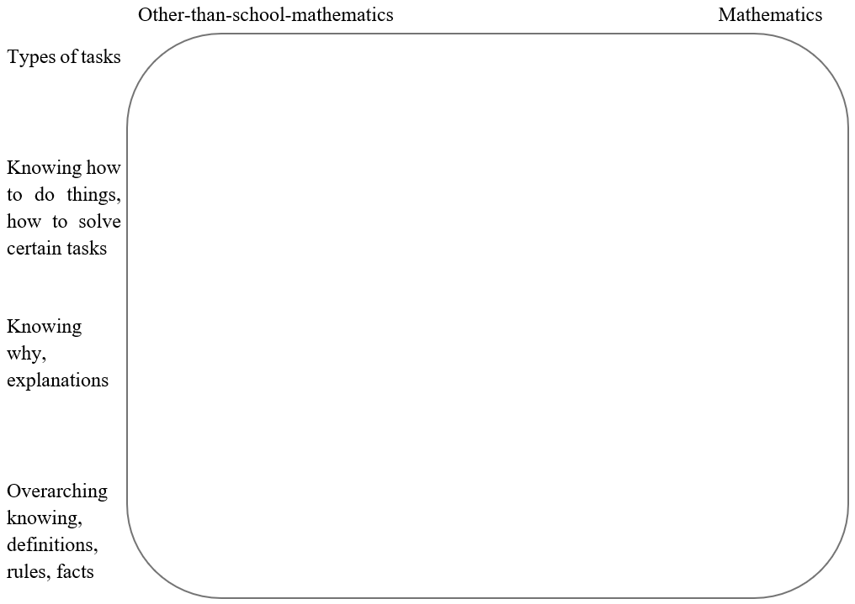
Figure 1. The framework (here empty) draws on Figure 5 in Johansson et al. (2024).
As shown in Figure 1, the space comprises two dimensions. One dimension, extending from left to right, illustrates a spectrum of knowing, showing other-than-school-mathematics in one end, and (school) mathematics in the other end of the continuum. What this dimension reveals is that the knowings involved in the task emerge through integrations between these two disciplines (including disciplines outside academia) of knowledge. Essential here is the idea that there could be any disciplines involved in the framework. As will be shown below, we have used different terms in the three cases below. All aspects along the continuum are integrated to some extent, while some aspects may mostly concern other-than-school-mathematical knowing (to the left) and some mathematical (to the right), but a lot is somewhere in the middle. The second dimension extending from top to bottom, illustrates different kinds of knowing, albeit not as a continuum as the horizontal dimension, for the requirements of the task/assignment/activity (from now on called task, but meant to be taken in a broad sense). At the top we can find the kind of task that is taking place. Below this, we find the methods and techniques that are used to work on the task, i.e. the knowing of how to do things, how to solve certain tasks. Further down, aspects are located that concern the knowing why, such as explanations of why a method works. Finally, we find, in the lowest part of the space, overarching knowing, including definitions, rules and facts, are located. The space notes the various activities that take place, in relation to the kinds of knowing they entail and how the disciplines are integrated. When exploring the transdisciplinary knowings that are brought forth through working on a certain task, the analysis needs to combine these two dimensions. Below, we present epistemological explorations of our three cases.
Vocational knowing and mathematics
The context for this first case is vocational education in Sweden, taking place as part of upper secondary school education, reflected in the image below (Figure 2) (see Boistrup et al., in ICMI study 27; Johansson et al., 2024). The Swedish national curriculum states that the teaching and learning of mathematics should be aligned with the knowledge content of the particular vocation. The vocation for this case is electrician, in which there are numerous matters of socio-ecological character to acknowledge for the future. Such matters cover environmental, social and economic sustainability, with the industry and workers playing a key role in the transition to a greener society. Of high relevance for this is installing energy-efficient technology and working safely and with material awareness. The case explored in this context is a task in the electrician workshop at the school, which reflects a job task occurring every time an electrician goes out on a job and when they pack the car. Here it is important to bring the right tools but also the material that will be used. Cable is such a material. Normally the electrician can choose between cable rolls in the company’s storage. To carry out a sustainable work, in the sense of not creating unnecessary waste, it is important to choose cable rolls with enough cable on, but also to not choose too long. This way it will be possible to save material. In Figure 2 the various activities, in relation to aspects of knowing, of carrying out this task are captured and put in the framework shown above in Figure 1.
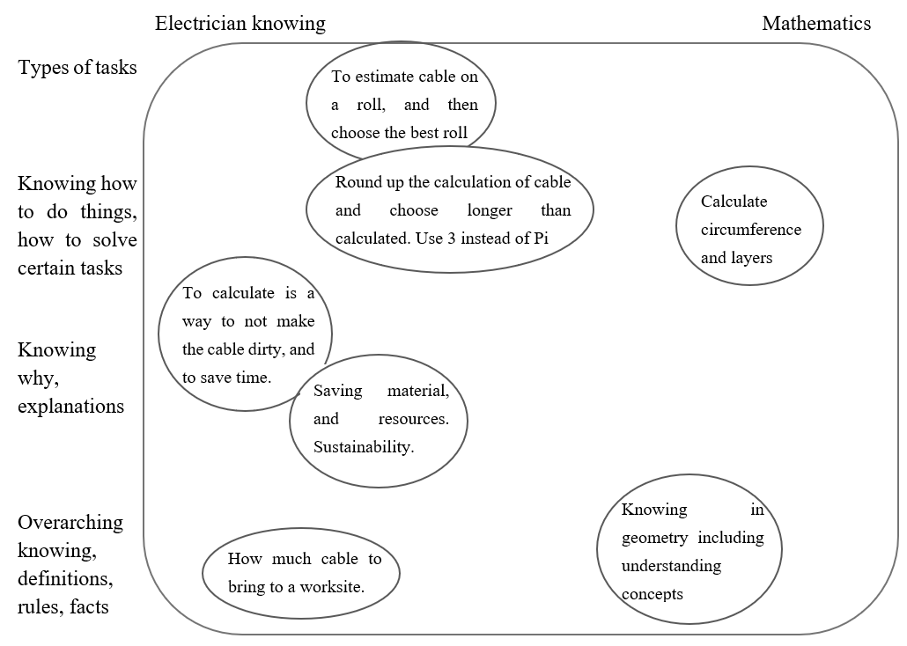
Figure 2.
The assignment in Figure 2, “To estimate cable on a roll, and then choose the best roll” serves as an example of how to address epistemological aspects in transdisciplinary teaching, which in this example has relevance for sustainable use of material. Since this task is very much part of the electrician vocation, but still holds a clear amount of mathematics, it is located a bit to the left at the top of Figure 2. The students might roll out the cable, measure and then roll it back in, leading to wear, tear and subsequent un-functionality of the cable, miss-using time and resources. A more socio-ecological way to solve the task is to use the diameter of the reel and the circumference of one layer, multiplied by the number of layers on the reel. On the one hand this method is a quite mathematical solution which is located to the right, “calculate circumference and layers”. On the other hand, the method is aligned with electrician knowing since the calculation uses 3 instead of Pi and asks the students to round up the answer. This way the students may arrive at an approximate value of how much cable is left on the reel, which can be used to save resources and for their future work to use a cable that is available rather than purchasing new cable.
Like other vocations, it is important not only to know how to solve problems, but also to know why certain methods are adopted. The vocational knowing for this example is to know how much cable is needed to bring to the work site. Here it is important to know about rules for electricity in buildings and also the knowings that stem from mathematics, mainly in geometry. It needs to be noted that the latter is not about “pure” mathematics, but mathematics as part of the electrician work practice, which is why it is located a bit to the left. A point we make, drawing on this case, is that it illuminates a transdisciplinary field which is far from a dichotomy, and far from a narrative where a vocational knowledge area is taken as only practical, while mathematics is viewed as the theoretical knowledge. Our case makes it clear that for future electricians, and other vocations, that both disciplines include knowing how and why to solve tasks. For a task like the one in the case, both disciplines are needed, and they are integrated, not least for the sake of socio-ecological awareness.

Contextualized Indigenous Mathematical Knowing
Indigenous mathematical knowing (indigenous knowledge systems) refers to the dynamic and locally grounded ways of knowing, practices, and beliefs that have evolved within specific communities over generations, often in close relationship with the natural environment (D’Ambrosio, 1985). In the context of mathematics education, it represents a distinct epistemological notion, one that is holistic, relational, and embedded in sociocultural and ecological contexts. Here we will use the framework in Figure 1, to reflect indigenous mathematics communities, in this case, the Sibuyan Mangyan Tagabukid, in relation to school mathematics. The Sibuyan Mangyan Tagabukid have their own inherent mathematical knowledge systems, ways of knowing and doing mathematics in their socio-cultural contexts (Fran & Vistro-Yu, in ICMI study 27). Like Oaxaca indigenous communities in México (Meléndez at al., in ICMI study 27), Sibuyan Mangyan Tagabukid utilize their knowledge of the socio-ecological as a point of reference in accomplishing certain tasks. One such task is to determine how to distribute the indigenous community members’ harvest, a concept associated with the product sharing practices of the Sibuyan Mangyan Tagabukid. Rooted in a relational ethics of care toward land, community, and the non-human world, this practice embodies a socio-ecological orientation to resource management that extends beyond mere economic calculation. Important for this indigenous context is that the distribution is just, which may not be to give all participants equal shares. Instead, the distribution is done through inupat, an indigenous practice that involves the distribution of harvest in four partitions, where the landowner gets one part and the tenant gets three. In this case, the landowner does not participate in the actual work of harvesting, although, in most cases, the family members of the tenant help him in harvesting.
The concept of partitioning, described as the process of breaking down a number or an object, as in this case the harvest, into smaller equal components highlights significant social and cultural practices of the indigenous community (Fran & Vistro-Yu, 2023). This practice encodes a socio-ecological position: the just distribution of yields is not merely a social agreement but a form of relational accountability – to the land that produces, the community that sustains and the non-human entities that make harvest possible. Just distribution of the yield and harvest of the indigenous community, both in agriculture and fishing, is anchored on the social values and beliefs embedded in the norms of the society. Such practice not only demonstrates the community’s inherent mathematical knowledge but also its socio-cultural ethics and ideals. In the case we explore below, we imagine how this partitioning activity may connect to future school mathematical activities, in a teaching where authentic examples derive from the indigenous context. Figure 3 shows the distribution of knowing in the task, “To determine how to justly distribute the harvest”.
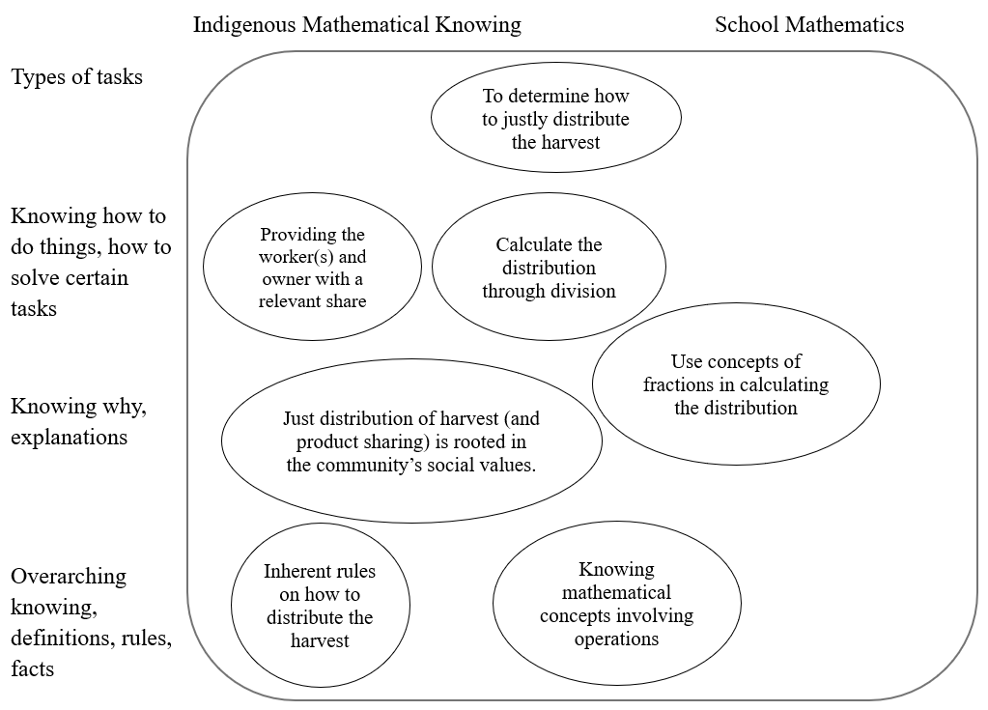
Figure 3. Contextualized Indigenous Mathematical Knowing
This contextualized task does not only enable students to solve a practical problem. Also, they utilize their indigenous mathematical knowing in figuring out a sustainable and viable solution, which can also be solved using school mathematics in a different approach. Hence the task is positioned in the center, illuminating how it may be connected to both indigenous mathematical knowing, and school mathematics with an interest in authentic examples of mathematics. One way of solving this task involves the distribution of harvest using an indigenous mathematical knowing perspective (explained above). This approach leans towards a more practical and inherent way of solving the task. That is why “providing the workers and owner with a relevant share” is positioned in the indigenous mathematical knowing dimension of the space. Simultaneously, we can see the involvement of knowing that also would occur in school mathematics, which is to “calculate the distribution through division”. In this context this is done materially with the crops directly. Hence, we have positioned this knowing in the center, incorporating both indigenous and school mathematics. Solving the task through indigenous knowing is rooted in the community’s social values, which is why this is positioned in the dimension of indigenous mathematical knowing within the continuum. These mindsets of indigenous community adhere to their own knowledge structures, and which is why they have established inherent rules on how to justly distribute their harvest, crops and yield, as part of their socio-cultural practices.
In working with this task, the students, as part of a school mathematical activity, may use the concept of division and partitioning to justly distribute the harvest among the number of workers involved. By using division, the students may also delve into the concept of fractions to mathematically represent the equal distribution of the harvest and yield. As shown in Figure 3 the positions of the knowings reflect the multi-dimensional perspectives in the framework, showcasing the different kinds of knowing and other related positionalities, relevant to future transdisciplinary education within the socio-ecological.

Early algebra and the socio-ecological
The context for this case is an ongoing research project (Jenny Fred, forthcoming), which involves systematically collaboratively imagining new possibilities for teaching and learning early algebra by incorporating Critical Mathematics Education (CME) (e.g Skovsmose, 1994) and the current socio-ecological crises facing the world (see Fred et al., in ICMI study 27). Here, the case we explore is an Algebraic Wicked Problem (AWP), named 'Does the table feel fair?', formulated by a research team consisting of teachers, pre-service teachers and researchers. This AWP was given to Grade 3 students within the context of an elementary school classroom in Sweden. The students were given a carbon footprint table (Figure 4) and were asked, “Does the table feel fair?” The table lists the carbon footprint values of various items and toys, using Cuisenaire rods.

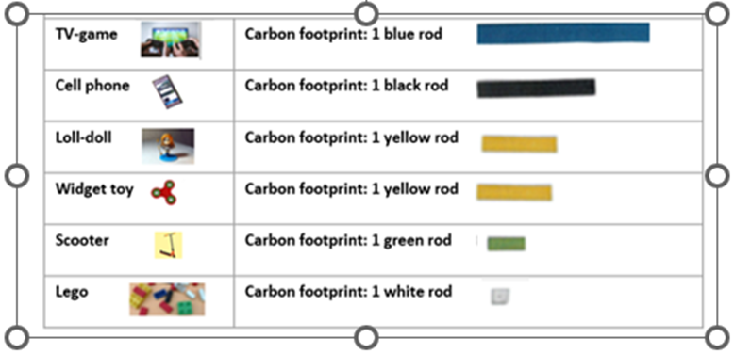
Figure 4: The carbon footprint table
The table above contains an inbuilt contradiction (Davydov, 2008) that invited the students to explore, interpret, analyze, and reason algebraically about abstract structures and possible corresponding relationships between given values for the items in the carbon footprint table. The inbuilt contradiction consisted of a value conflict between the items’ economic and carbon footprint values. Specifically, some cheaper objects had a higher value compared to more expensive ones. For instance, an inexpensive LOLL-doll has a higher carbon footprint compared to a more expensive scooter. This discrepancy highlights the value-conflict between economic cost and the durability of items. This conflict allowed algebraic aspects to unfold, significantly connecting to socio-ecological aspects. In Figure 5 below, we utilize the transdisciplinary space from Figure 1 to illustrate various aspects of knowing that may be mobilized in students' work with the AWP described above. The task was for the students to determine whether the table was fair, and then to explore and reflect on the carbon footprint values provided in a table.

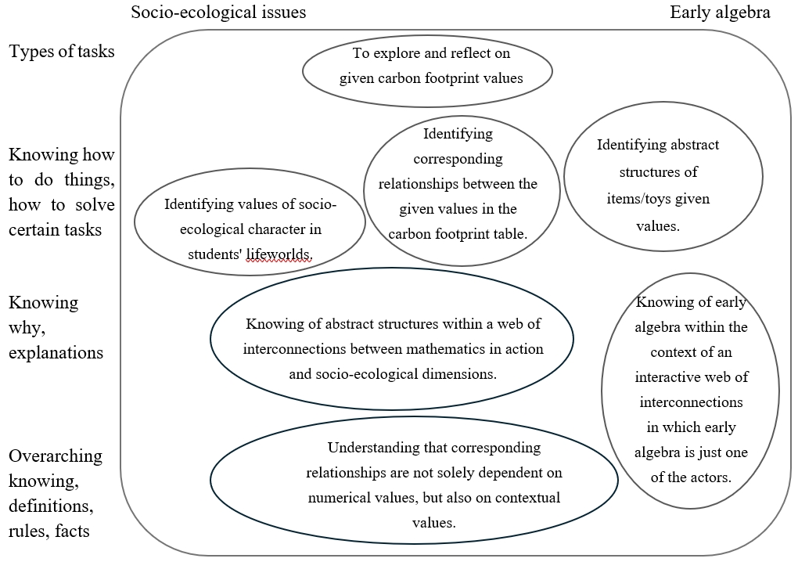
Figure 5
The task is located at the top center of Figure 5. The reason for this is that when students explored and reflected on the given values, aspects of both socio-ecological and algebraic character came into play. In this work, students started to reason about the value-conflict by saying things like “That little LOLL-doll cannot be much more than Lego, can it?, “And then the scooter... Scooters are big...”, “But you have a scooter for a really long time... And there are a lot of other things than just plastic.”. The students were solving the task by recognizing the durability of different toys based on their materials, that is, “identifying abstract structures of items/toys given values”, based on their durability value. This is located to the right, early algebra, in Figure 5, because the identification of abstract structures is in the foreground. The students also identified the items' durability value as a corresponding relationship between the given values, which is located in the center of Figure 5, because when students were “identifying the corresponding relationships”, socio-ecological and algebraic aspects became integrated simultaneously. The durability value can be viewed as a measure of socio-ecological character, as it encompasses dimensions of sustainability. Additionally, scooters and LOLL-dolls are familiar to students, aged 7-9, so they are items that are part of the students' lifeworlds. This means that the students were “identifying values of socio-ecological character in students' life-worlds” by addressing the durability of materials and by reflecting on how items like scooters can last a long time, located on the left side of Figure 5, in the socio-ecological dimension.
“Knowing of early algebra within the context of an interactive web of interconnections, in which early algebra is just one of the actors” concerns how the knowing of early algebra is not self-existing. Instead, it is embedded within a web of interconnections that also comprise mathematics in action, the formatting power of mathematics, and socio-ecological issues within students' life-worlds (e.g., Skovsmose, 1994). This knowing is seen as becoming mobilized in the students' work with the AWP, which helps explain the ways of solving the task, not least in how early algebra and the socio-ecological may relate to each other. Therefore, it is located more in the center of Figure 5.
“Knowing of abstract structures within a web of interconnections between mathematics in action and socio-ecological dimensions” illuminates how it is through abstract structures that the interconnection between mathematics in action and socio-ecological dimensions can be explored and reflected upon. By identifying underlying abstract structures within mathematics in action that are of a socio-ecological dimension, we can gain insight into abstract values, thereby facilitating the visualization of the relationship between power and mathematics in action (e.g., Skovsmose, 2023). In other words, it is only upon identifying these abstract values that students can engage in critical reflection and exploration of the formatting power of mathematics (Skovsmose, e.g., 1994). This knowing is also seen as a means for explaining why and what becomes mobilized in the students' work with the AWP. It is located on the right side of Figure 5 because the early algebra is in the foreground. “Understanding that corresponding relationships are not solely dependent on numerical values, but also on contextual values” concerns how abstract structures are not solely contingent on their numerical value, but also on their contextual value. This means that the contextual value can vary depending on what has been identified as the underlying structures. Consequently, the emphasis is placed not solely on intrinsic mathematical correlations and connections, but rather on mathematics interacting with socio-ecological aspects. This is seen as an overarching knowing that becomes mobilized in the students' work with the AWP. Hence, it is located more in the center of Figure 5 because the socio-ecological and early algebraic aspects come into play simultaneously in the students' work.

Digging into the complexity and changing structures: interrelational epistemology
Considered with the complexity of becoming to know, Abtahi (2022) describes Interrelational epistemology, as a way of becoming to know things, that considers learners as selves-in-relations rather than isolated individuals and knowing as an understanding of one’s position in webs of inter-relationality. Abtahi (in ICMI study 27) builds on the significance of storytelling to elucidate key elements of this epistemology. Other scholars have conceptualized the role of stories, emphasizing their affective power to motivate students, sustain engagement, and foster broader meaning-making in relation to the world around them (e.g. Altintas, 2018). Stories are commonly understood as narratives that convey experiences, events, or ideas, often involving characters and settings. However, their significance in the context of interrelational epistemology extends beyond these structural elements. Stories function as powerful tools for meaning-making, enabling the connection of abstract concepts to lived experiences, emotions, and broader social and cultural understandings. Their epistemological value lies not only in their content but also in their affective and relational dimensions—how they engage other ways of knowing, personal experiences, emotions, and values, in the process of becoming to know.
Within this epistemological view, knowledge is understood as an awareness of position: not fixed or universal, but rather emerges through relationships—between people, places, non-human beings, and the more-than-human world. As these relationships shift and evolve, so too do the ever-changing knowings they generate. Mathematics, in this context, is reimagined as a system of knowing that can illuminate our interconnectedness and interdependence with the world around us (see Abtahi, 2022 for further discussion). This is where the importance of stories becomes magnified, as mentioned in Abtahi (in ICMI study 27). Storytelling and listening act as pathways to knowing that position the learner as a relational self. When stories are told and heard through different systems of knowledge—such as mathematics—they can reveal our positions within broader ecological and social networks through a web of nodes and lines, see Figure 6.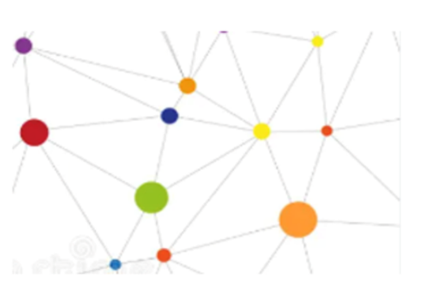
Figure 6
Figure 6 offers a visual representation of this epistemological structure including learners, and the other representing knowings. These visual elements embody the relationality, illustrating how individuals are always in relation to multiple entities, and how knowing is inherently fluid, interconnected, and responsive to the movement and transformation of those relationships.
When an element (knowing) is added to the structure, the whole structure of all knowing dynamically changes. For example, when we hear a story, learn a mathematical concept, etc a new, in this case pink, node is added to the interconnected knowing. As a result, the green node and the orange node that were in the front in Figure 6, they move their location, see Figure 7.
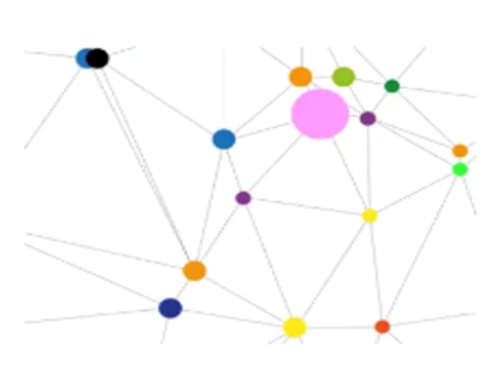
Figure 7
Over time, and adding of the stories and knowings, nodes may disappear, lose their importances, or become signified. In the following, we explore the cases again through the lens of interrelational epistemology to further signify the complexity of knowing.

Changing structures of Vocational knowing and mathematics
When returning to the vocational case, we view the task and the work around it as a story of how to measure cable when you are an electrician, including all the interrelated factors that are needed to consider. We also view it as a story which all students experience in different ways. Here is a variety of knowings in play, and also teachers, other students, materials, personal matters et cetera. When exploring this case through the lens of interrelated epistemology by Abtahi, we follow an imaginary student called Sara, and her experiences when getting to know about measuring cable, for her future vocation. Sara is imaginary, but she is built on the work with students and teachers that were part of the data for Johansson et al. (2024), so it is a likely, albeit potential, scenario that we describe.
We start by interpreting the aspects of knowing that Sara experiences in the beginning of working on this task, where the teachers ask the students to figure out how much cable there is on a roll. These aspects of knowing are related to other kinds of elements, which all are shown as nodes in a web related to other nodes in the web (Figure 8). Larger nodes signify those that were more in focus to Sara at a certain moment, while smaller nodes are not taken as of high relevance to her. This is even more the case when the writing is in smaller letters. The lines reflect how Sara experiences relations between the nodes in the web. Some lines are thicker, with more weight, reflecting stronger relations. This web is constructed as being Sara’s experiences in the beginning of the story.
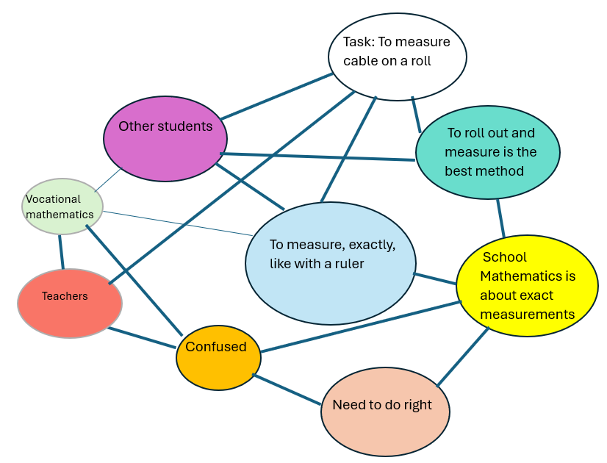
Figure 8: The first web of Sara’s experiences when finding the length of a roll of cable.

When the story of finding the length of a roll of cable is in its beginning, as reflected in Figure 8, Sara’s system of knowledge consists of methods and rules deriving from her previous experiences of measuring lengths with a ruler or with a measuring tape. These are related to values, such as how measurements need to be exactly done (large light blue node) which is strongly related to how it is highly important to get it right (peach colored node). The activity takes place in the electrician workshop at the school, so it is clear to Sara that this is a vocational task. The electrician teacher’s presence also indicates that the task has relevance for an electrician, but so far in the story this has not been discussed further. A consequence is that Sara connects the measuring with school mathematics (thick line), while vocational mathematics is distant and vague (thin line). Sara can sense from the teachers that the electrician context is important so she feels a bit confused. Sara’s solution to the task, as the other students’, is to roll out the cable and measure it with measurement tape.
Figure 9 reflects the next web for Sara. This takes place later during the activity and the story that Sara is experiencing. The teachers had a discussion with the students about how measuring a cable can be done for a working electrician. In this discussion it was made clear that rolling out the cable runs a great risk of the cable becoming dirty, and thereby useless. In this new web, some new nodes have entered the story, and the web is dynamically changed, not least in relation to what aspects of knowing are present.
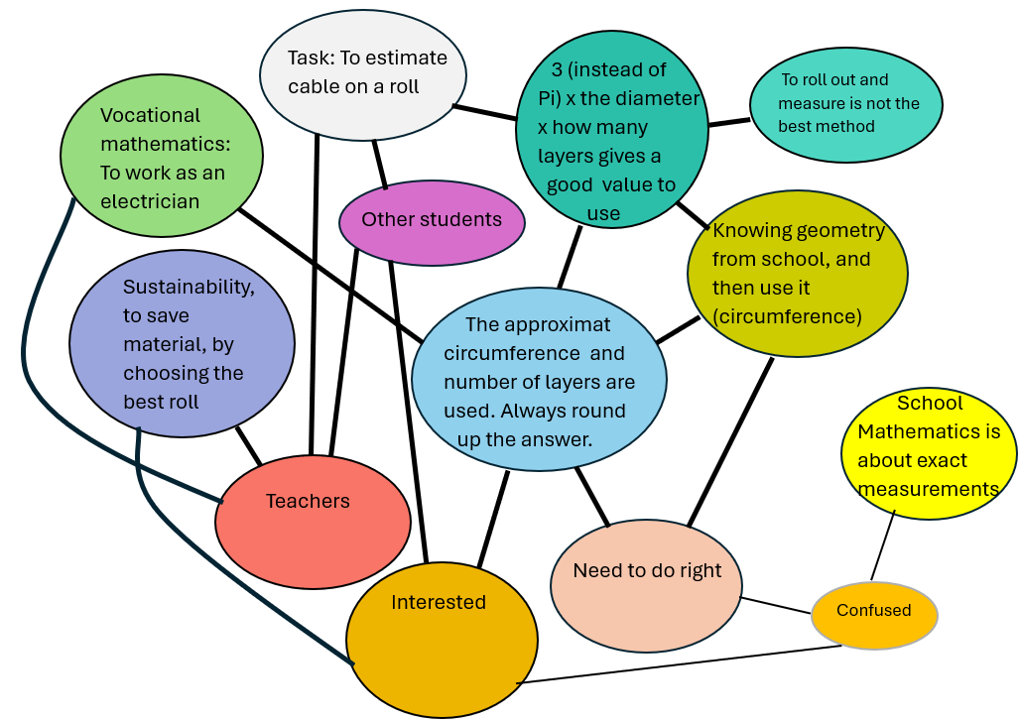
Figure 9. The second web of Sara’s experiences when finding the length of a roll of cable.

The second web in Figure 9 illuminates several changes for what Sara is experiencing after working on the assignment, with guidance from the teachers, and side-by-side other students. A clear change is that the number of nodes has increased, and that nodes have changed size Another kind of change in the web is that several nodes have moved around and they are also slightly altered, which is signified with a small change of color. One example here is how the assignment is phrased, where it is clear that it is not about actually measuring the cable, but to estimate the length. This is clearly connected (thick line) to the teachers who emphasized this aspect from the point of view of an electrician (larger and developed node). This led to both another method (multiplying 3 with diameter and layers) and other values, such as sustainability, and choosing the best roll (not too long or too short). It is also possible to see that school mathematics has a changed role, where some confusions are still there in relation to exact measurement, as in school, but also how geometry in school can be of use in the electrician’s work, although a bit altered. Finally, it is possible to see how Sara has started to feel interested, which is clearly related both to sustainability and the reasoning about how to solve the task, where both teachers and other students had roles to play.

Changing structures of Contextualized indigenous mathematics knowings
Using Abtahi’s (in ICMI study 27) perspective of interrelational epistemology, this section will show the changing structures within the indigenous mathematical knowings presented from the experiences, lens, and story of a fictional student named “Renren” as he answers the assignment. This stemmed from the perspective of solving a task from the lens of a member of an indigenous community who is immersed in various indigenous knowledge systems and practices. From the view of epistemological relationality, hearing such stories through a system of knowledge, in this case indigenous mathematical knowings, makes us become aware of our positions towards everything that we are in relation to and interdependent with. In this perspective, a learner, such as Renren, is viewed not as an individual but as a self who is in relations (Abtahi, in ICMI study 27).
Working with the task of determining how to justly distribute the harvest, the epistemological relationality framework (see Figure 10) shows that Renren can do and solve the task the typical approach, by utilizing school mathematics. As shown, school mathematics is in relation (represented by nodes of larger sizes) with the other knowings of the web particularly with the use of division and fractions in calculating just distribution among workers and others. As Renren solves the task, he may do it by solely using fractions or it can happen the other way around. This shows that knowing and how a learner deals with the task may change depending on how he understands and perceives the relationships surrounding the web of school mathematics in terms of just distribution. As shown, line segments vary in thickness reflecting the strength and level of relationship the nodes have with other nodes in the web.
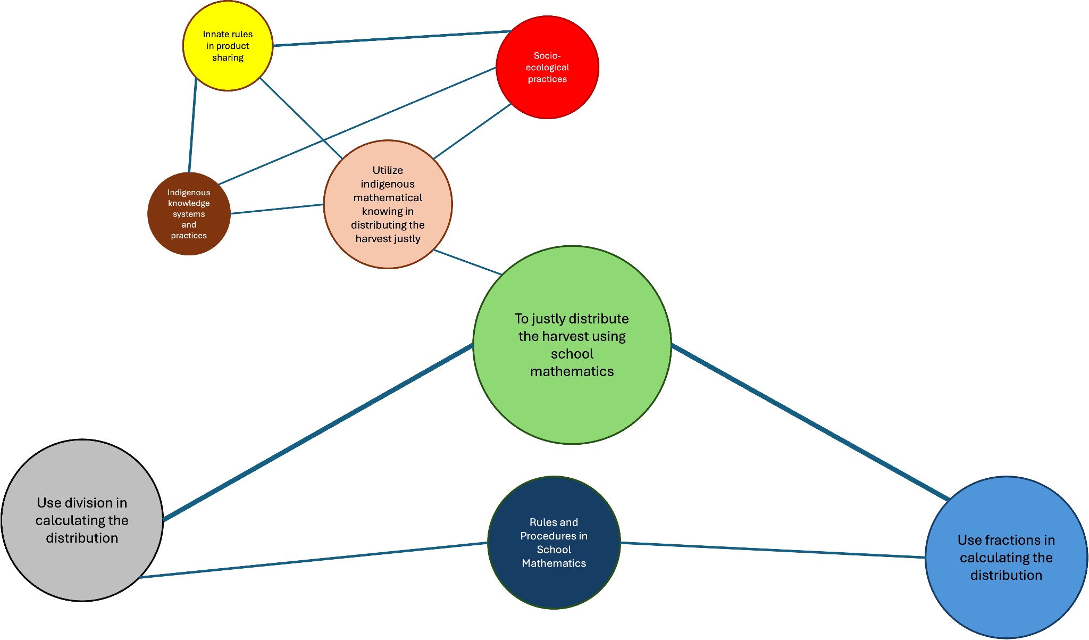
Figure 10. Renren’s first web of experiences as he solves how to justly distribute the harvest
As Renren solves the task, as shown in Figure 10, it can be noted that greater connections are depicted showing how he solves it by using the typical approach of solving such a task, through division as well as the use of fractions. This illustrates the importance given to these nodes while Renren is solving the task with school mathematics as his reference. Though Figure 10 shows that Renren may have solved the task using other perspectives, such as indigenous mathematical knowing (illustrated by the smaller nodes with thinner segments), this was not given greater emphasis at this phase where the teacher allows them to explore and solve the problem in a way they see fit. Since the teacher has not yet discussed how indigenous mathematical knowing can be used in such a task, Renren has focused his attention in utilizing school mathematics, through the concepts of division and fractions, in justly distributing the harvest.
As the teacher explained and discussed how to solve the task using other approaches, particularly on using indigenous mathematical knowing, Renren tried to work with the assignment from a different perspective as shown in Renren’s second web in Figure 11. In explaining the indigenous mathematical knowings behind justly distributing the harvest, other nodes in the web were highlighted and given greater value and significance by the teacher. In effect, there were some changes in the sizes of the nodes as well as in the thickness of the segments connecting the nodes in the web.
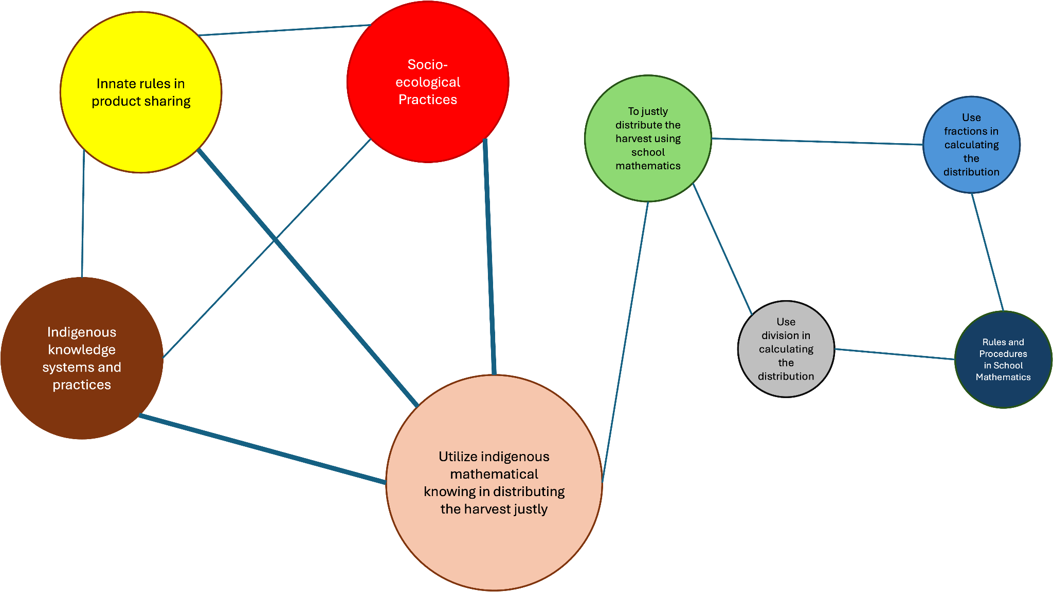
Figure 11. Renren’s second web of experiences as he solves how to justly distribute the harvest
Renren’s second web, as shown in Figure 11, illustrates how his view changed when introduced to solving the task from a different lens, in this case, through indigenous mathematical knowing. Compared to the first web, the thickness of the segments connecting the nodes in the web changed as well as the sizes of the nodes, signaling a shift on how Renren viewed the knowings with respect to its importance. There have been movements on how the nodes are positioned in the web demonstrating the constantly changing nature of the nodes. This implies that when a learner, such as Renren, works on tasks like this, the degree of importance of the knowings might vary depending on how he perceived something to be helpful in solving the task. This results in the shrinking of some of the nodes in the web which he viewed to be of little significance at this point in time. In solving the task, Figure 11 depicts that indigenous mathematical knowing can be utilized in distributing the harvest justly. Indigenous mathematical knowing further exhibits strong relation (segments with thicker sizes) with the indigenous knowledge systems and practices including the innate rules of product sharing and partitioning which are essential when analyzing how to distribute the harvest justly. These connections demonstrate the essential role that these knowings, in which Renren is in relation to, are playing while he is trying to figure out how harvest can be justly distributed.

Changing structures of Integration of socio-ecological into early algebra in relation to school mathematics
In this section, we again explore the case of early algebra and the socio-ecological perspective, focusing on the changing structures within dynamic webs of interrelatedness. The story concerns an imaginary student, Elton, who is confronted with different knowings of abstract structures and corresponding interrelationships. Furthermore, this story will visualize how the teachers’ actions enable various kinds of dynamic webs of inter-relationality to emerge. Consequently, two webs will be considered. Each web comprises, together with the knowings of abstract structures and corresponding relationships, the elements of the student’s life-worlds, a carbon footprint table, C-rods, and critical evaluations. However, the characteristics and the interrelations of these elements change between the two webs. Furthermore, there are elements that are only present within one of the webs.
The first version of the web in Figure 12 is related to knowings that Elton experienced when he was invited, with other students, to create a joint budget limited to two orange C-rods. These knowings include recognizing abstract structures and identifying corresponding relationships within an interrelational web of various nodes. In this case, these nodes relate to the relationships between given values, materialized by C-rods, and the quantitative relationships between the lengths of different C-rods, all of which are interconnected within an interactive web.

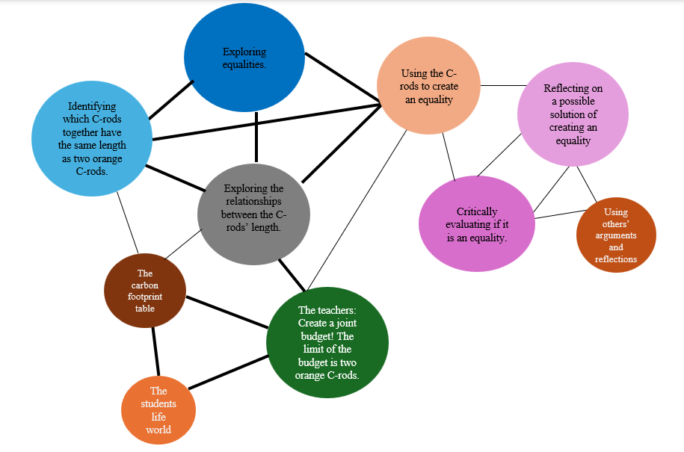

Figure 12
This story begins with the teacher asking the students to create a limited joint budget by using C-rods (the green node). When Elton and his classmates begin working on creating this joint budget, different elements (as reflected by the nodes) come into play. These nodes are not separated from each other or from Elton. Instead, they are coming in relation to one another and to Elton. Furthermore, these nodes have different characters and varying degrees of prominence (as visualized by the different sizes of the nodes and the thickness of the lines in Figure 12). The task is related to the socio-ecological issue of carbon footprint (the brown node) and the students' life-worlds (the orange node). The node “students' life-worlds", in this context, refers to the items in the carbon footprint table. These items are within these students' life-worlds, in other words, in their current play activities. Elton’s system of knowledge consists of methods and rules deriving from his experiences of exploring numerical relationships to create equalities. Furthermore, in this web, Elton’s experiences of abstract structures and corresponding relationships come in relation to nodes such as exploring equalities (dark blue node), exploring relationships between the C-rods' length (grey node), and identifying which C-rods together have the same length as two orange C-rods (light blue). These nodes of exploration and identification are then in relation to other, such as using the C-rods to explore and create equalities (beige node), reflection, arguing, and critically evaluating different solutions with others (the orange and the two pink nodes).
The second version of the web is related to Elton’s experiences when he was invited, with other students, to reflect on the question “Is the table fair?”. This question allows a different web of interrelations to emerge. In other words, different nodes come in relation to one another and Elton. Furthermore, the knowing of abstract structures and corresponding relationships are connected to other kinds of nodes than in the web in Figure 13.
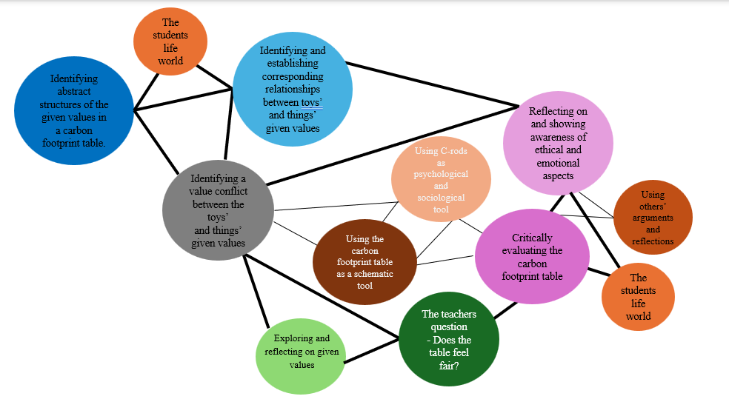
Figure 13
Zooming in on what is changing in the structure of the first web to the second web in Figure 13, the teacher's question in the second web invites a different kind of exploration and critical evaluation. That means that Elton’s experiences are interrelated with his life-world (the two orange nodes) in a broader sense. In other words, both regarding the exploration and reflecting on given values (light green) and critically evaluating the carbon footprint table (the darker pink node). In the first case, the interrelationships concern Elton, the identification of a value conflict (grey node), the identification of abstract structures (dark blue node), and the identification and establishment of corresponding relationships (light blue node). In the second case, the interrelationships concern Elton, specifically the reflection on and awareness of ethical and emotional aspects (lighter pink node). In this second web, there is also a strong interrelation between the identification of corresponding relationships (light blue node) and the reflection on ethical and emotional aspects (lighter pink node). That means, early algebra is here interconnected with the world around us, which also includes emotional and ethical dimensions concerning real-world sustainability situations.
In essence, the teacher's pedagogical actions, in terms of the questions they pose or the tasks they assign to students, bear implications for both the kinds of nodes that emerge and the interrelations that emerge between these nodes and Elton. In other words, the teacher’s action plays a crucial role when the structures of the interrelation web change, and also when the knowings a student comes into relation with as a self change.

Towards an interrelational future of mathematics education
This chapter has argued that mathematics knowing is relational: it comes to life in and through relationalities among learners, disciplines and practices, places, materials, values, and more-than-human conditions. Viewing mathematics knowing as relational has been argued by others, such as de Freitas (in ICMI study 27): “Abstraction is also a key mode of imagining otherwise and exploring alternative modes of relationality and belonging, and as such it is a key creative mode in both art and science” (p. 78). Others have also addressed the bringing together of different frameworks. For example Le Roux and Motala (in ICMI study 27) explore how to (re)story mathematics education interactions and its in-between becomings, as varied scales operate within complex socio-ecological territories, by bringing together cartographic science and critical posthuman cartography. What our chapter offers concerns methodological tools to be adopted for how relational knowing can become mobilized in different contexts of mathematics education. In this final section, we suggest that bringing together the two frameworks of the chapter, transdisciplinarity and interrelationality, in a future-oriented lens allows knowings to meet and to be integrated in transdisciplinary education. It also reflects how students’ knowings are reconfigured within shifting webs of relations. Furthermore, this future-oriented lens foregrounds socio-ecological challenges, making them an integrated dimension of mathematical activity itself, in the future. Our discussion below follows three lines of addressing the future, where the first addresses the two frameworks, the second the three cases, and the third bringing them all together.
First line: Looking towards an relational future, we read transdisciplinary education and interrelational epistemology together as practical lenses for two aspects of relational epistemology: the epistemic work that takes place when different disciplines meet and are integrated and ways a student’s knowing might be shaped in relation to others (human and non-humans) and to available resources. The transdisciplinary space (Figure 1) helps to specify where and how different knowings meet in an educational practice (e.g., school mathematics, vocational practices, indigenous communities, and the socio-ecological concerns). It also offers a language for designing and analysing tasks where different knowings meet. Interrelational epistemology brings the knower clearer into the exploration, showing how that knowing reconfigures as relations shift; it makes visible ethical concerns, positions, dependencies, and response-abilities as epistemic matters rather than add-ons. It also offers a language for engaging in those spaces: it foregrounds the learner as a self-in-relations whose knowing is continuously reconfigured as new nodes enter, disappear, or change value in the web. In other words, in combination, these two frameworks move from just adding context to mathematics towards a future including the rethinking of what counts as mathematics knowing, for whom, and with what responsibilities. Furthermore, when they are used together, the frameworks support both a) identifying the socio-ecological within mathematics education practice, and b) designing for simultaneous integration so that neither mathematics nor the socio-ecological is reduced to a mere resource for the other.
Second line: The three cases in this chapter, drawn from different educational and socio-ecological contexts, illustrate a dynamic and uncertain character of knowledge and ways of knowing mathematics for and in the future. Across the cases, the transdisciplinary framework makes visible what knowing is integrated and where possible tensions emerge between mathematical and socio-ecological aims. Interrelational epistemology adds to tracing how learners’ ways of knowing are continuously formed in relation to others, both human and non-human, and to the resources and constraints that particular practices may entail. For example, rather than treating algebraic knowing as an isolated skill set, it can be understood as an interconnected web that becomes visible through students’ relating and structuring in action—across (a) early algebra and mathematical activity, (b) early algebra and the organizing or formatting power of mathematics, and (c) the wider socio-ecological conditions that shape what learners encounter, value, and can act upon (see Fred, forthcoming). Together, the cases point toward a future mathematics education in which learners, communities, and planetary resources are not background contexts, but conditions that shape what is learned and what becomes meaningful to learn.
Third line: Taken together, these explorations call for re-imanging the relationalities and fluidities of the future of mathematics educations, including social and ethical response-abilities. From this standpoint, mathematics becomes a means to notice and reason with interdependence in the human and more-than-human-world.
Within these relational orientations, questions of identity, place, responsibility become central to what counts as mathematical knowings. For example, in the case of the Sibuyan Mangyan Tagabukid, their identity is constructed through their interdependent relationships with their environment. Their mathematical practices, such as the fair distribution of the harvest (inupat), are not simple calculations, but rather the embodiment of their communal social, ethical, and ecological values (Fran & Vistro-Yu, in ICMI study 27, pp. 456–463). This indigenous identity (Dei and Jaimungal, 2018) we view as also a future imagining within scientific/Western where mathematical learning is shaped by and contribute to ongoing socio-ecological relations. In turn, this future-oriented framework reframes what we take as evidence for knowing and learning, thereby opening ways to imagine relational futures in mathematics education.
References
Abtahi, Y. (2022). What if I was harmful? Reflecting on the ethical tensions associated with teaching the dominant mathematics. Educational Studies in Mathematics, 110(1), 149–165. https://doi.org/10.1007/s10649-021-10117-1
Abtahi, Y. (2026). In the teaching of mathematics part of ethical responsibility is toward a shared sense of solidarity and commitment. The Philosophy of Mathematics Education Journal, 43, 1-10.
Altintas, E. (2018). Analyzing Students' Views about Mathematics Teaching through Stories and Story Generation Process. Educational Research and Reviews, 13(7), 249-259.
Barwell, R., Boylan, M., & Coles, A. (2022). Mathematics education and the living world: A dialogic response to a global crisis. The Journal of Mathematical Behavior, 68, 101013. https://doi.org/10.1016/j.jmathb.2022.101013|
Boistrup, L. B., & Hällback, M. (2022). Designing and researching vocational mathematics education. In L. B. Boistrup & S. Selander, Designs for Research, Teaching and Learning (1st ed., pp. 61–81). Routledge. https://doi.org/10.4324/9781003096498-5
Boylan, M. (2017). Towards a mathematics education for ecological selves: Pedagogies for relational knowing and being. Philosophy of Mathematics Education Journal, (32).
Capone, R. (2022). Interdisciplinarity in mathematics education: From semiotic to educational processes. EURASIA Journal of Mathematics, Science and Technology Education, 18(2).
Carrillo Catalán, R, Santillán Nieto M., & Morales Meléndez Q. (2026). Un ejemplo de un panorama de investigación en Oaxaca, México: Saberes matemáticos indígenas para fortalecer su identidad y fomentar la reapropiación de sus prácticas matemáticas originales. Proceedings of the 13th International Conference on Mathematics Education and Society (To appear). MES Community.
Chen, G. A. (2023). Teacherly response-ability: Ethical relationality as protest against mathematical violence. Educational Studies in Mathematics, 114(2), 277-296.
D’Ambrosio, U. (1985). Ethnomathematics and its place in the history and pedagogy of mathematics. For the Learning of Mathematics, 5(1), 44-48.
Davydov, V. V. (2008). Problems of developmental instruction: A theoretical and experimental psychological study. New York: Nova Science.
Dei, G. J. S., & Jaimungal, C. S. (2018). Indigeneity and decolonial resistance: An introduction. En G. J. S. Dei & C. S. Jaimungal (Eds.), Indigeneity and decolonial resistance: Alternatives to colonial thinking and practice. Myers Education Press.
Fran, F.A. & Vistro-Yu, C.P. (2023). Mathematical knowledge structures of socio-cultural communities: The case of Sibuyan Mangyan Tagabukid. Proceedings of the ICMI Symposium on Mathematics Education and the Socio-Ecological. ICMI.
Gutiérrez, R. (2019). Mathematx: Towards a way of being. In Subramanian, J. (Ed.), Proceedings of the 10th International Mathematics Education and Society conference. MES
Gutiérrez, R. (2022). A spiritual turn: Toward desire-based research and Indigenous futurity in mathematics education. Journal for Research in Mathematics Education, 53(5), 379–388. https://doi.org/10.5951/jresematheduc-2022-0005
Johansson, T., Boistrup, L. B., & Dahl, J. (2024). Patterns of connections between mathematics and electrician knowledge: Praxeology in vocational education. Quaderni di Ricerca in Didattica, 13, 641-650.
Maheux, J. F., & Roth, W. M. (2011). Relationality and mathematical knowing. For the Learning of Mathematics, 31(3), 36-41.
Skovsmose, O. (1994). Towards a critical mathematics education. Educa-tional Studies in Mathematics, 27(1), 35–57. https://doi.org/10.1007/BF01284527
Skovsmose, O. (2023). Critical mathematics education. Springer. https://doi.org/10.1007/978-3-031-26242-5
Todd, K. L. (2018). Dreaming our way to new decolonial and educational futurities: Charting pathways of hope. In G. J. S. Dei & C. J. Jaimungal (Eds.), Indigeneity and decolonial resistance: Alternatives to colonial thinking and practice (pp. 191-209). Myers Education Press.

A LOLL-doll is a small toy doll that comes hidden inside a ball with multiple layers to unwrap, where each layer contains small accessories and a surprise

